**CHAPTER 4**

**RESULTS AND DISCUSSION**

**4.1 Connection Results**

**4.1.1 Factory I/O and Codesys**

The connection between Factory I/O and Codesys can occur within the IoT system. The experiment conducted using a ready-to-use scenario, moving Item from point A to point B, and the PLC program that consists of 3 variables. These variables connected to Factory I/O using addresses that already shown in section **3.2**.

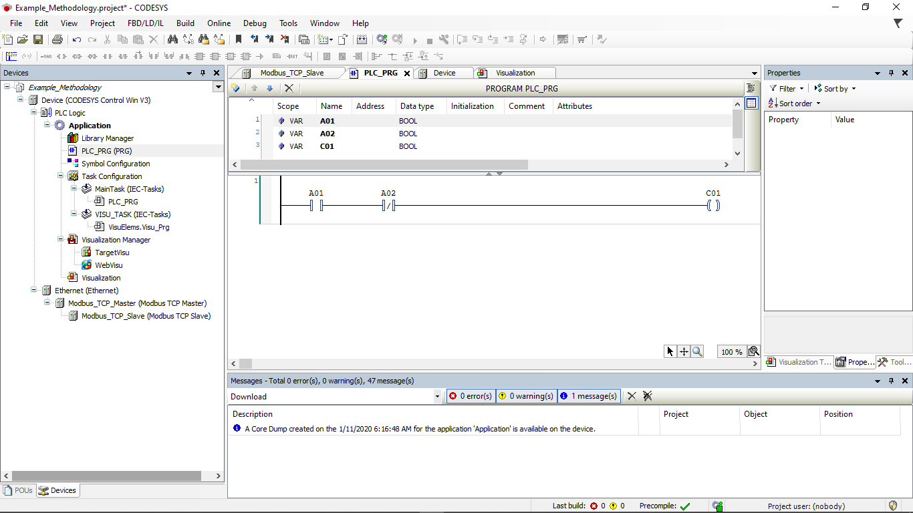

**Figure 4.1** PLC Program in Codesys

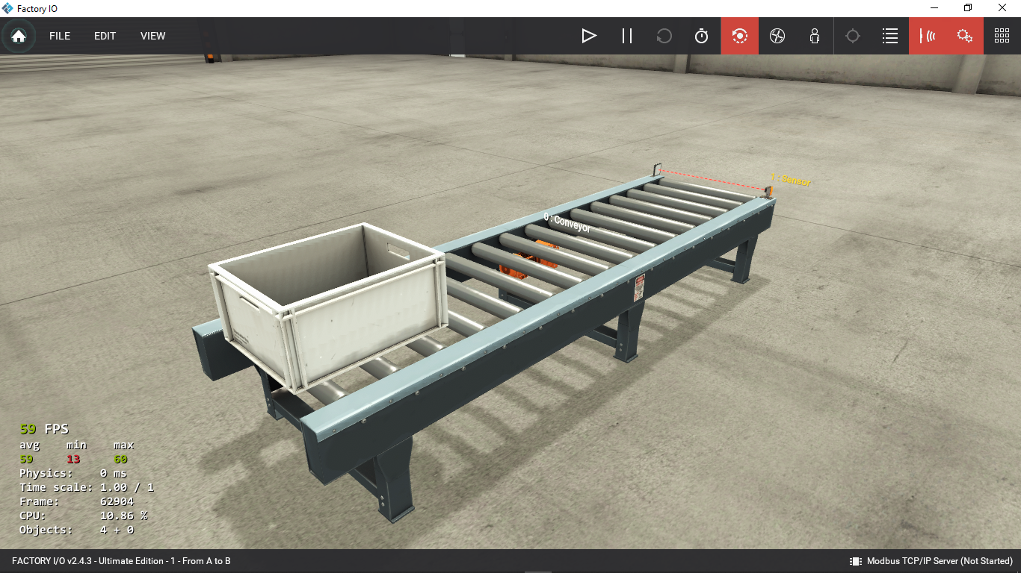

**Figure 4.2** “From A to B” scenario

The Ladder Diagram PLC program was used to conduct the experiment “From A to B”. The simple experiment consists 1 contact, 1 negated contact and 1 coil. The value of A01 acts as conveyer start moving needs to be TRUE so the item will travel from point A to B. The Sensor indicator lamp will go off if the item pass through the Sensor.

The variables then need to be assigned in the Modbus TCP Slave I/O Mapping, the configuration is shown in **Figure 4.3**

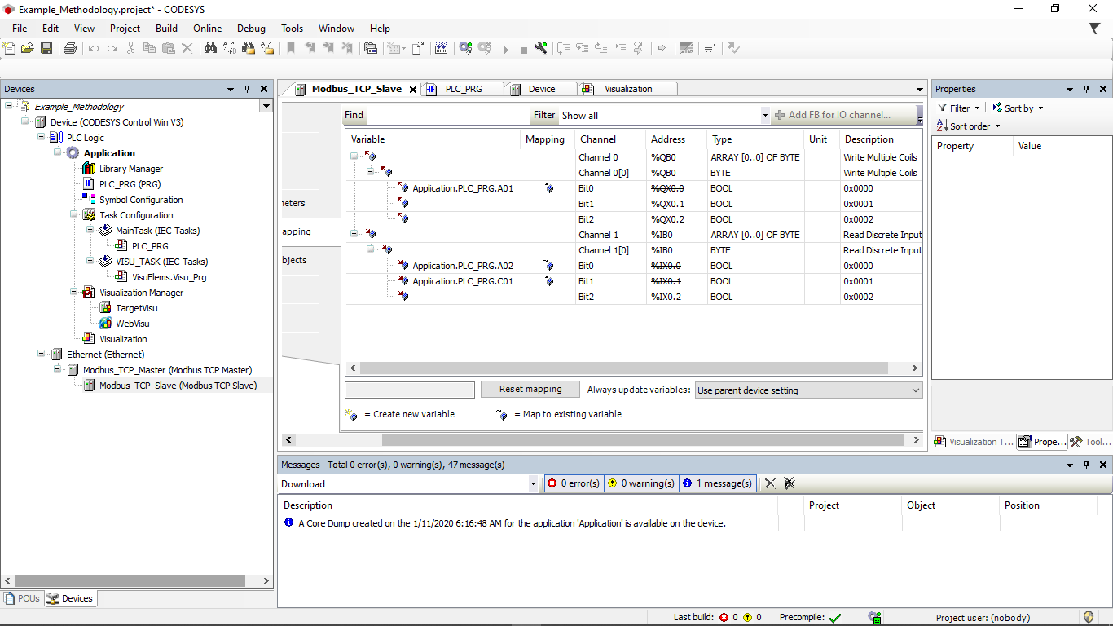

**Figure 4.3** I/O Mapping of the experiment for Factory I/O and Codesys

The variable can be transformed into a control panel, allowing us to act as if we were a real operator. We can create a virtual control panel using Visualization. A simple control panel was built Visualization as is shown in **Figure 4.4**

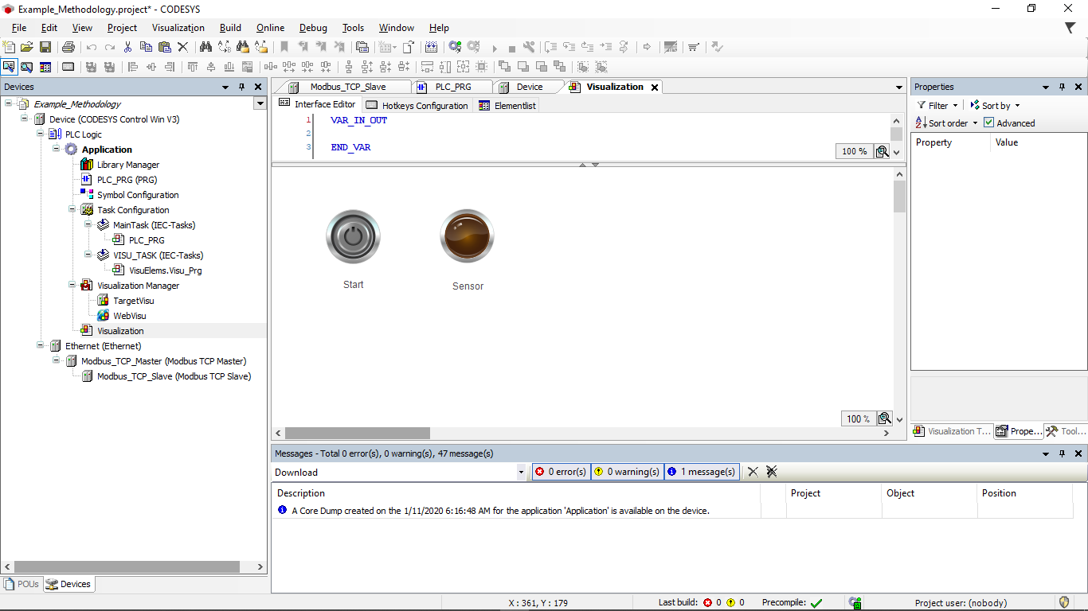

**Figure 4.4** Visualization of The Control Panel

**4.1.2** **Flow Chart of Sorting 3 Different Materials**

Before create the scenario in Factory I/O, defining the flow of the sequence is crucial. By understanding the mechanism of each component in Factory I/O library, I create my own flow chart to sorting 3 different materials. The flow chart shown in **Figure 4.5**

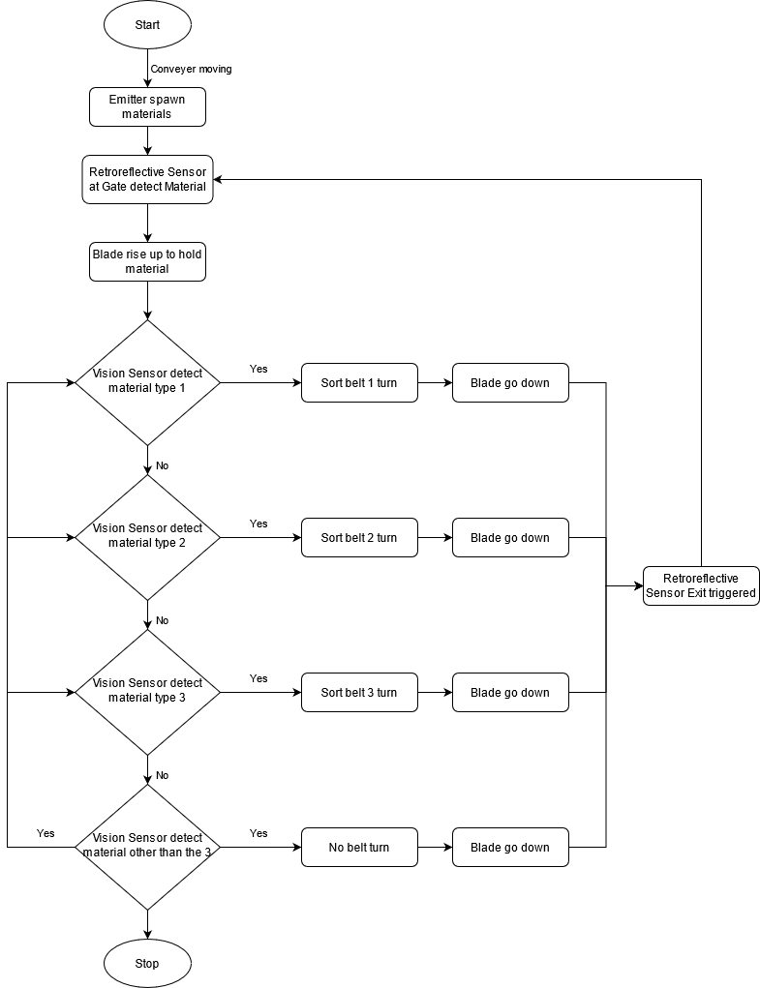

**Figure 4.5** Flow Chart of Sorting 3 Different Materials

**4.1.3 Create The Sorting Scene**

The sorting Sequence was built within Factory I/O by utilizing the components of Factory I/O library. The scene was built within a short amount of time, as shown in **Figure 4.6**.

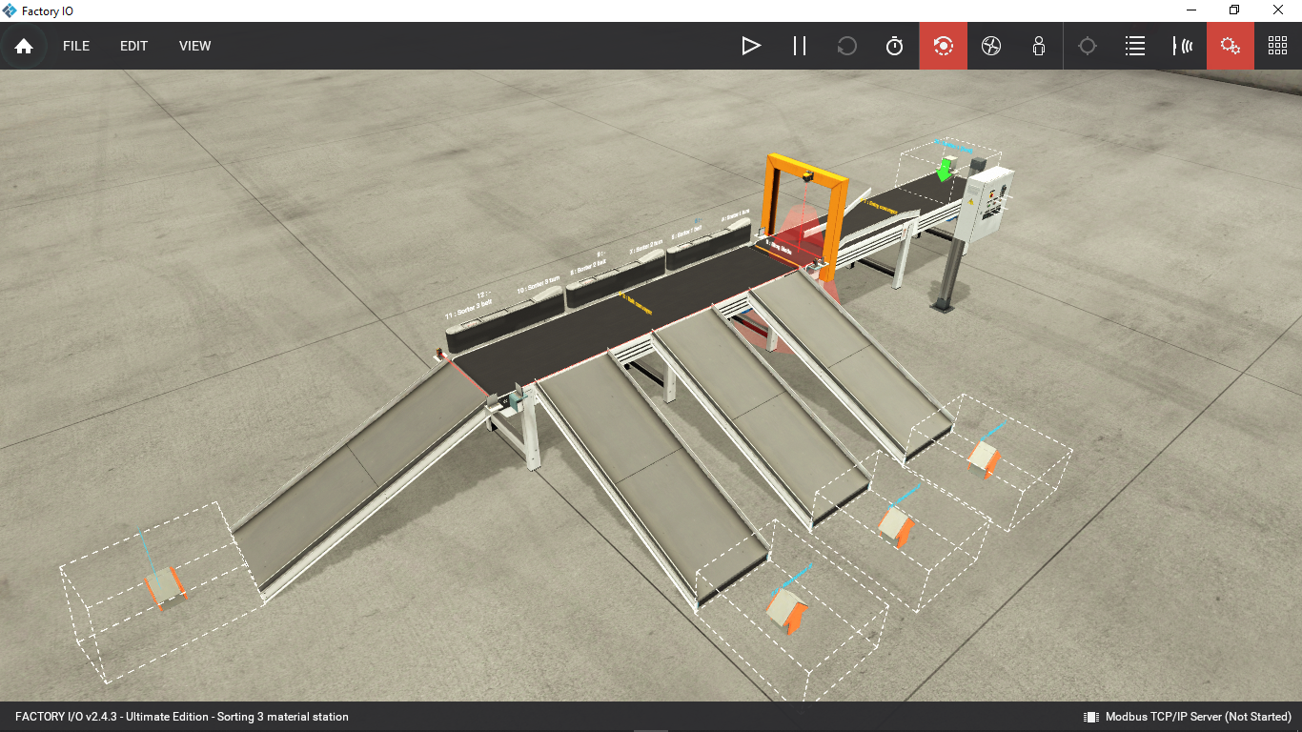

**Figure 4.6** OverviewofSorting 3 Different Materials

**4.2 Integration between Factory I/O and Codesys**

As stated in the previous chapter, the connection between Factory I/O and Codesys is possible and works well with the experiment. As stated in **Chapter 1**, the experiment in this section is to combine all of those devices into a single IoT system, the design architecture of the IoT system is shown in **Figure 3.1.** In the system, virtual PLC Control Win V3 becomes the controller of the sorting scene in Factory I/O. The experiment program in Factory I/O was executed in Codesys.

**CHAPTER 5**

**SUMMARY, CONCLUSION, RECOMMENDATION**

**5.1 Summary**

This thesis establishes an IoT system for communication between two devices, Factory I/O and Codesys. The goal of this thesis is to combine such devices into a single IoT system that can run effectively and generate the desired output.

The experiment in this thesis was to run a sequence of three materials sorting in Factory I/O from Codesys. The result was to create a production line capable of separating three materials according on the type of materials randomized by the emitter; in this situation, the emitter became the supplier. The Modbus Communication Protocol is used to connect two separate devices into a single IoT system. The information was provided by each device manageable thanks to the I/O Drivers from Factory I/O that were already capable of communicating with the Modbus Communication Protocol. The results demonstrate that Codesys could connect and control Factory I/O by utilizing Modbus.

**5.2 Conclusion**

During this research project, several conclusions are made, which are:

1. The integration of the IoT system could be achieved and worked effectively to provide the desired outputs.

2. In an IoT system, Codesys can be used as an HMI and controller of a simulated sequence in Factory I/O.

3. The Factory I/O library is not customizable; they give very general components, potentially limiting the user’s freedom and creativity.

Despite the conclusion number 3, the objective of Factory I/O is to help users learn about the components available in the factory line and how to use them in the simplest way possible; it is not an application for building a full-scale factory.

To sum up, this thesis proposes a practical way for integrating many devices into a single IoT system. The communication protocol is broad, and Factory I/O already has a built-in feature to support in communicating with other devices that use a variety of communication protocols. Individuals or industries could utilize the data from this thesis to build an IoT system.

**5.3 Recommendations**

This section discusses recommendations for anyone interested in developing the results of this study. These theses are meant to be guidelines, providing insights into future research on subjects where the Factory I/O itself has so many options to work with yet does not provide a choice of components with specific brands. Or, at the very least, the library can be added to or altered from the outside. Perhaps in the future, downloadable content (DLC) containing extra components will be available for purchase to aid the user's creativity.

As a final point, the production line scene used in this IoT system needs to be modified to become more efficient, more effective, and visually appealing. This can be done with having better preparation and creativity to create the production line.